419-333

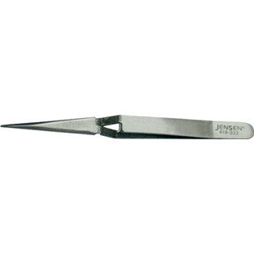

Jensen Tools TWZ-935.00-J Reverse-Action Tweezer
Manufacturer Model Number: | TWZ-935.00-J
Part Number: | 419-333
Shipping Weight: | 0.04 pounds

Product Description
Nickel-plated carbon steel, 4-3/4" long, pointed tips. Good heat sink.

