CAL-MN-C
DC-6 GHZ PRECISION N-MALE CALIBRATION OPEN/SHORT/LOAD
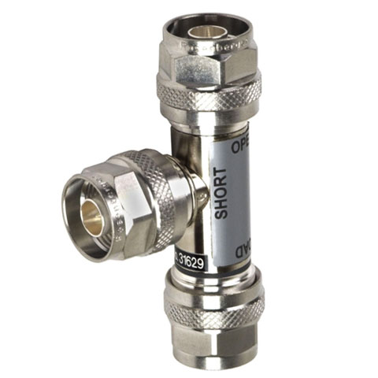
Impedance | 50 ohms
Return Loss | -40 dB @ DC-2.5 GHz | -38 dB @ 2.5-6.0 GHz
Frqeuency Range | DC to 6 GHz
Finish | Brass | Nickel
Power Rating | 1 W
Connector | N (M)
Inner Conductor | Beryllium Copper/Gold
Outer Conductor | Brass/Gold
Weight | 0.53 lbs

